**VIRTUAL PROGRAMMING LANGUAGES  
PROJECT ON**

**HOTEL MANAGEMENT SYSTEM**

**INSTRUCTOR:**

**DR. NOMAN ISLAM**

**MEMBERS:**

**SM. HARIS QADRI (12386)**

**FILZA (13819)**

**HMS USING WEB FORM**

**INDEX**

**TopicsPages**

1. Objectives 1
2. Executive Summary 1
3. Introduction 2
4. Features 3
5. Problem Statement 3
6. Work breakdown structure 4
7. Future plan 4
8. References 5
9. Screenshots 6

**HOTEL MANAGEMENT SYSTEM**

**Objective:**

Main objective of this project is to provide solution for hotel to manage most there work using computerized process. This software application will help admin to handle customer’s information, room allocation details, payment details, billing information.etc.

The project, Hotel Management System is a web-based application that allows the hotel manager to handle all hotel activities online. Hotel management project provides room booking, staff management and other necessary hotel management features. The system allows the manager to post available rooms in the system

**Executive Summary:**

Hotel industry is an essential part of tourism. The expansion of tourism is well inevitable bringing out development of the hotel industry. Hotel industry is so closely linked with the tourism industry that it is responsible for about 50% of the foreign exchange earnings from tourism trade and enterprises.

The hotel industry in recent year’s government has taken several steps to boost travel & tourism which have benefited hotel industry in Pakistan.

Marriot Hotels, PC and Regent Plaza covers a wider market in the hotel industry than the other luxury hotels in the race. They have a better product profile than the rest: i.e. they have great management, hospitality and facilities provided by them to their customers. This project is based on secondary data. I have collected the all information from secondary data like internet, journals, book etc.

The objective of taking up this research is to create a Global Market Positioning System for the hotels that can balance their maps and strategies for a financial well being. The researcher wished to relate to the hotel market segmentation, redefinition of the hotel services and brand competencies. At the backdrop of such a conducive business atmosphere 'Pre-feasibility Report on Five-star Hotel Industry' attempts to examine such critical factors which will provide vital inputs in general to the potential investors and estimation of commercial viability of such an investment.

**Introduction:**

The theme of my Project is Hotel Management System. This Project is a fine thought to make the complex procedure of the Hotel management system to an easy manner which is systematic, modular designed, selective menu based user display. The modular design and constructed system is very much user oriented in which user can easily understand the tools and can do edit of his own choice. The system is not any tough more and does not possesses many applications but it is made by focusing on the maintaining records employee’s actions in a computerized system rather than time taking and cumbersome manual system.

The project is a software application that can be easily handled by minimum educated and simple computer knowledge person without any option of error. Two kinds of users can handle the system.

1. Online Users, 2. Administrator or Hotel Management.

The Online users are the customers or the staff who can see the news and updates of the Hotel and the Administrator are responsible for updating the Hotel details on computer. The Administrator is the authorized user who has power to change or edit the updates as well as the Password. In case of the forgetting of password there is provision to password recovery and Logout and Login in the system.

The Purpose of the whole process is to ease the daily or regular activities of the Hotel Management into an automatic computerized retrievable process. The daily activities includes the Room activities, Entering details of the new customer check in, To allocate a room as per the customer need and interest, Recording the checkout time and details, Releasing or Empty of room and to record the process in a computer system for future.

Due to time constraint and the minimum resources, the system is not made for the high level use. But the Management system can use the application in a very easy and minimum effort.

**Features:**

* Different types of Rooms
* Selecting facilities
* Select time and days
* Online payment
* Online reservation
* Online quotation

**Problem Statement:**

Tourist information centers spend a lot of their time calling hotels to check for availability. Also, many smaller hotels suffer from not being able to advertise their availability to tourist information centers. The Aptos Chamber of Commerce, a tourist information center in Santa Cruz County, currently has no automated system for managing information about hotel availability and must call each hotel individually. They would like a more efficient system to route tourists to local hotels with availability while saving valuable time that could be invested in other community services.

**Proposed Solution:**

The process of finding hotel availability could be automated to save time for both the tourist information center staff and the hotel staff. We propose a system that allows hotel staff to add listings to a central database via a website. The tourist information center staff could then open an application to access the database, and retrieve information about the number of rooms available and their prices.

**Work Breakdown Structure:**

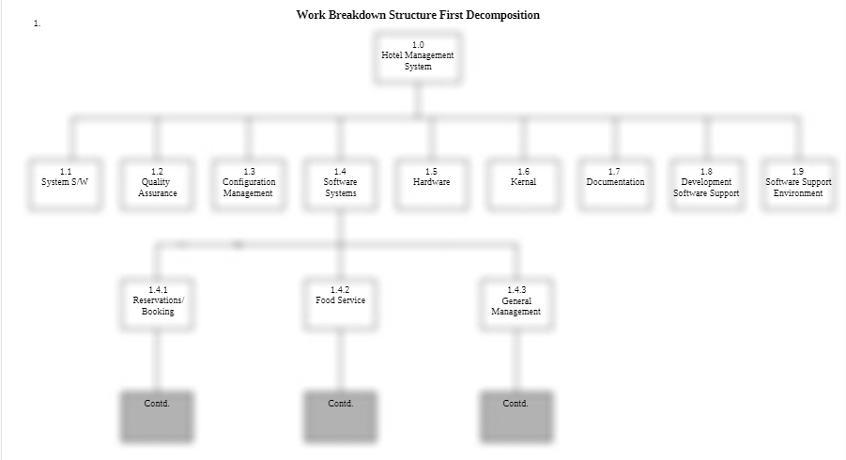

**Future plan:**

The scope of hotel management ranges from housekeeping and general cleaning to providing customer service. A manager is responsible for everything that happens in the hotel, so the scope for the job generally covers everything that goes on in the hotel. The future scope of hotel management students is high due to the rising tourism across the world

**References:**

* <https://www.scribd.com/document/137284211/Work-Breakdown-Structure>
* <https://www.answers.com/Q/What_is_the_future_scope_for_hotel_management_students>
* <https://www.scribd.com/doc/36955127/Executive-Summary-Hotel>
* <https://1000projects.org/hotel-management-system-project-report.html>
* <https://www.docsity.com/en/users/signup/>
* <https://www.academia.edu/2112330/A_SAMPLE_HOTEL_MANAGEMENT_SYSTEM_PROJECT_DOCUMENTATION>

**Screenshots:**

